 

***OIE Director General on an official visit to the Russian Federation***

***10-12 October 2018***

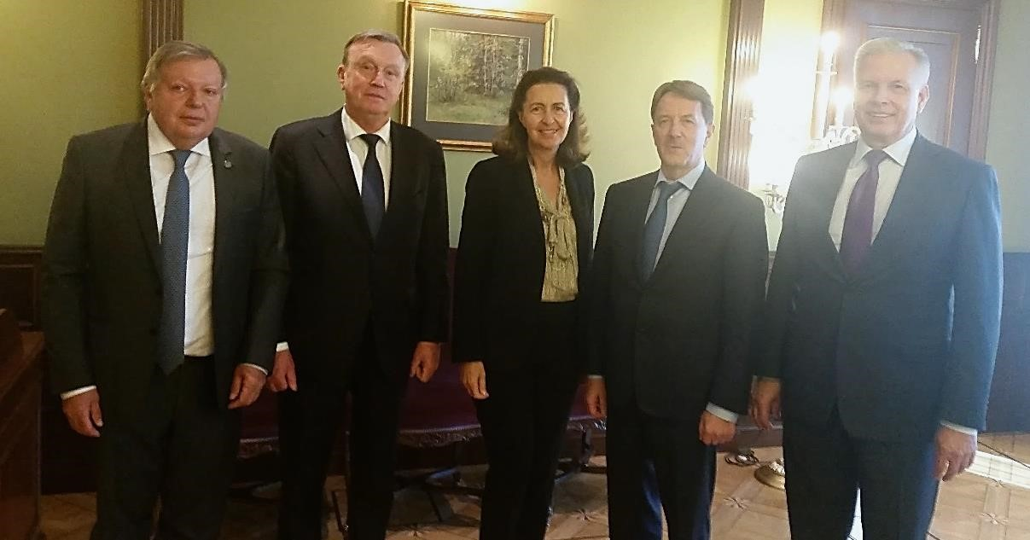

From left to right: Dr Romano Marabelli, Dr Kazimieras Lukauskas, Dr Monique Éloit, Mr Aleksey Vasilyevich Gordeev and Mr Sergey Dankvert.

The Russian Federation invited OIE Director General, Dr Monique Éloit, to attend a ministerial panel last month that was organised within the framework of the Agribusiness Forum ‘Golden Autumn’, on the theme of ‘Agriculture Export as a Driver of Industry Modernization’. This mission was a great opportunity to meet up with the highest authorities in Russia, in particular with the Deputy Prime Minister in charge of Agriculture, Mr Aleksey Vasilyevich Gordeev, as well as with the Head of the Federal Service for Veterinary and Phytosanitary Surveillance (*Rosselkhoznadzor*), Mr Sergey

Dankvert. The agenda of the meeting with Mr Gordeev mainly addressed the situation of African Swine Fever (ASF) in both Europe and China, and the prospect of developing a vaccine. The active involvement of Russia in the GF–TADs meetings and associated expert groups has been recognised as a positive contribution towards the better control of ASF in Europe, thanks to the sharing of information and experiences. Emphasising the importance of transparency on the epidemiological evolution of animal diseases, Dr Éloit encouraged Mr Gordeev to consider the engagement of Russia in the WAHIS+ project, particularly in the second phase of the project related to the interconnectivity of data systems.



1

www.oiebulletin.com

***The OIE Director General attends the official opening of the OIE Regional Representation Office in Moscow.***

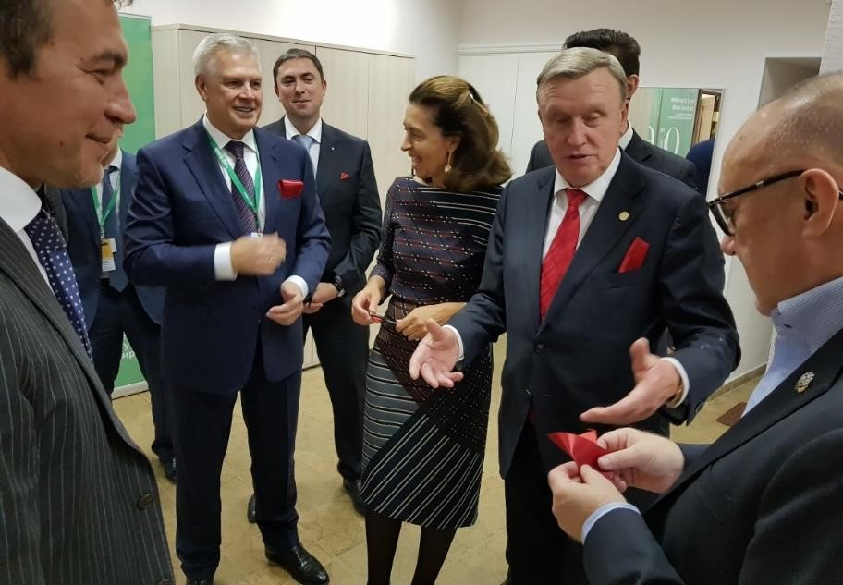Dr Éloit continued her visit in Russia, by participating in the official opening ceremony of the OIE Regional Representation Office in Moscow. OIE Regional Representatives gave a presentation on their activities since 2013, the year in which the OIE signed an agreement with the Russian Federation on the office’s creation. Mr Dankvert and Dr Éloit cut the ribbon, formalising the opening, and guests were invited afterwards to visit the facilities over a celebratory drink.

***Dr Éloit wrapped up her mission with a visit to the ARRIAH Laboratory of the Vladimir Institute attending the 60th anniversary of the founding of the Institute.***

The ARRIAH Institute is located on the outskirts of Vladimir city. Dr Éloit started her visit with a brief overview of several facilities, including a small portion of animal houses. Currently, the facilities are undergoing important refurbishments – some old laboratories are being completely revamped, while new laboratories are being built. The OIE Director General subsequently opened the ceremony marking the 60th anniversary, taking the opportunity to highlight the important role played by the OIE Reference Centre in providing scientific expertise for various purposes, most notably to support Member Countries, provide data and information to the OIE Biological Standards Commission and/or within *ad hoc* groups, and participate in training workshops. Dr Éloit congratulated the ARRIAH community for its commitment over many years to its role as an OIE Reference Laboratory. Before closing the ceremony, she specifically acknowledged certain scientists for their active contribution, awarding them with honorary diplomas. The OIE Director General was then invited to plant a maple tree onsite to mark the occasion of this 60th anniversary celebration.

 November 2018



2

# www.oiebulletin.com